

**Fundamentals of Programming**

**ASSIGNMENT # 1**

**NAME** : Daniyal Ahmed

**CLASS** : ME-15

**SECTION** : B

**ROLL NO.** : 457165

**DATE** : 2-OCT-2023

**HOME TASKS**

**//TASK # 1**

//#include <iostream>

//using namespace std;

//int main ()

//{

// double a=6 ,b;

// cout<<"Factorial of 6 = ";

// b=a*(a-1)*(a-2)*(a-3)*(a-4)*(a-5);

// cout<<b;

// return 0;

//}

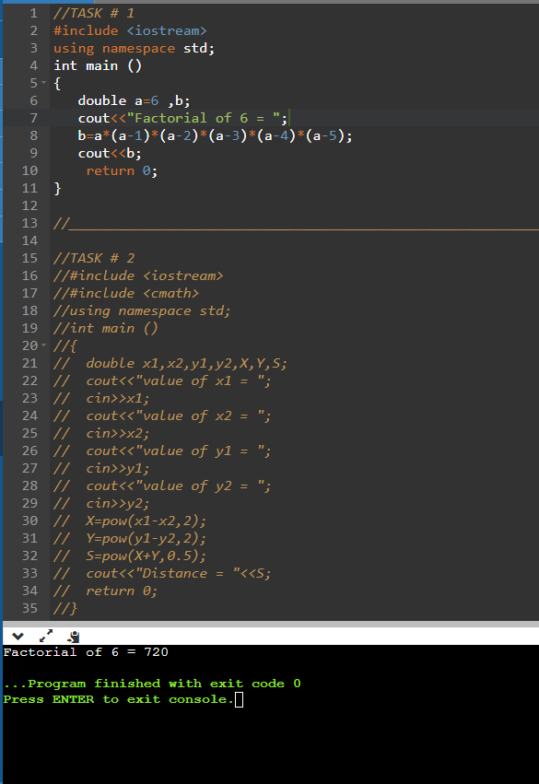

//____________________________________________________________________________

**//TASK # 2**

//#include <iostream>

//#include <cmath>

//using namespace std;

//int main ()

//{

// double x1,x2,y1,y2,X,Y,S;

// cout<<"value of x1 = ";

// cin>>x1;

// cout<<"value of x2 = ";

// cin>>x2;

// cout<<"value of y1 = ";

// cin>>y1;

// cout<<"value of y2 = ";

// cin>>y2;

// X=pow(x1-x2,2);

// Y=pow(y1-y2,2);

// S=pow(X+Y,0.5);

// cout<<"Distance = "<<S;

// return 0;

//}

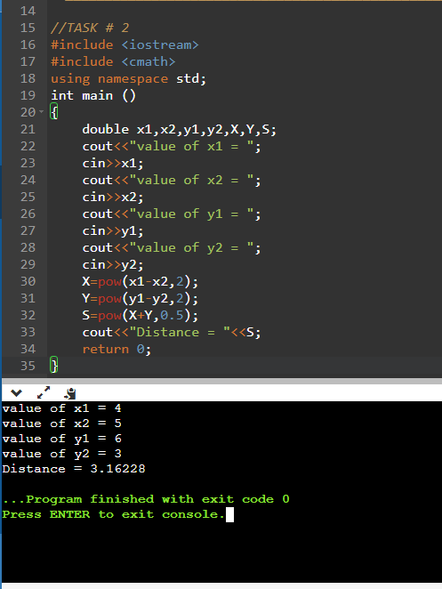

//____________________________________________________________________________

**//TASK # 3**

//#include <iostream>

//#include <cmath>

//using namespace std;

//int main ()

//{

//

//double centimeter,meter,kilometer;

//cout<<"put\n";

// cout<<"value in centimeter = ";

// cin>>centimeter;

// meter=centimeter/100;

// kilometer=centimeter/100000;

// cout<<"then ;\n";

// cout<<centimeter<<" centimeters = "<<meter<<" meters"<<endl;

// cout<<centimeter<<" centimeter = "<<kilometer<<" kilometers";

// return 0;

//}

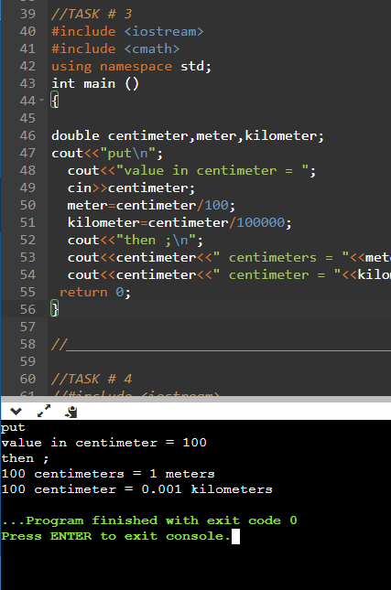

//____________________________________________________________________________

**//TASK # 4**

//#include <iostream>

//#include <cmath>

//using namespace std;

//int main()

//{

// double a,b,c;

// cout<<"value of a = ";

// cin>>a;

// cout<<"value of b = ";

// cin>>b;

// c=pow(a,2)+2*a*b+pow(b,2);

// cout<<"(a+b)^2 = "<<c;

// return 0;

//}

//



